Print Out Source Code Program

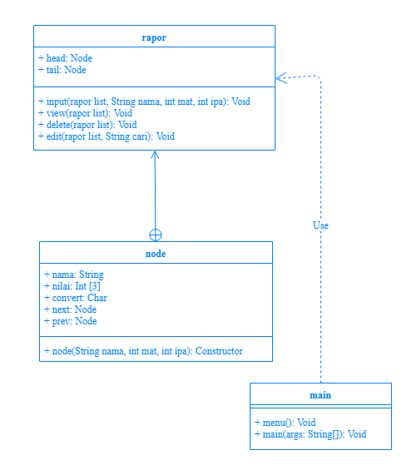

Print Out Source Code Program

class rapor {

Scanner in = new Scanner(System.in);

private static class node{

String nama;

int[] nilai = new int[3];

char convert;

node next,prev;

Keterangan Source Code :

------------------------------------------------------------------------------------------------------------------------------------------------------------------------------------------------------------------------------------------------------------------------------------------------------------------------------------------------------------------------------------------------------------------------------------------------------------------------------------------------------------------------------------------------------------------------------------------------------------------------------------------------------------------------------------------------------------------------------------------------------------------------------------------------------------------------------------------------------------------------------------------------------------------------------------------------------------------------------------------------------------------------------------------------------------------------------------------------------------------------------------------------------------------------------------------------------------------------------------------------------------------------------------------------------------------------------------------------------------------------------------------------------------------------------------------------------------------------------------------------------------------------------------------------------------------------------------------------------------------------------------------------

Print Out Source Code Program

node(String nama, int mat, int ipa){

this.nama = nama;

this.nilai[0] = mat;

this.nilai[1] = ipa;

this.nilai[2] = (mat+ipa)/2;

if (nilai[2]>=80){

this.convert ='A';

}else if(nilai[2]>=50 && nilai[2]<80){

this.convert = 'B';

}else if(nilai[2]>=30 && nilai[2]<50){

this.convert = 'C';

}else{

this.convert = 'D';

}

this.next = null;

this.prev = null; }}

node head,tail;

Keterangan Source Code :

------------------------------------------------------------------------------------------------------------------------------------------------------------------------------------------------------------------------------------------------------------------------------------------------------------------------------------------------------------------------------------------------------------------------------------------------------------------------------------------------------------------------------------------------------------------------------------------------------------------------------------------------------------------------------------------------------------------------------------------------------------------------------------------------------------------------------------------------------------------------------------------------------------------------------------------------------------------------------------------------------------------------------------------------------------------------------------------------------------------------------------------------------------------------------------------------------------------------------------------------------------------------------------------------------------------------------------------------------------------------------------------------------------------------------------------------------------------------------------------------------------------------------------------------------------------------------------------------------------------------------------------------

Print Out Source Code Program

void input(rapor list, String nama, int mat, int ipa){

node data_siswa = new node(nama, mat, ipa);

if(list.head == null){

list.head = data_siswa;

list.tail = data_siswa;

}else{

data_siswa.next = list.tail;

data_siswa.prev = null;

list.tail.prev = data_siswa;

list.tail = data_siswa;}

System.out.println("Data Telah Ditambahkan\n");}

void view(rapor list){

node view = list.head;

System.out.println("Nilai Siswa\n");

while(view != null){

System.out.println("Nama= "+view.nama+"\nNilai Matematika= "+view.nilai[0]+

"\nNilai IPA= "+view.nilai[1]+"\nRata-Rata= "+view.nilai[2]+

"\nHasil= "+view.convert+"\n");

view = view.prev;

}

}

Keterangan Source Code :

------------------------------------------------------------------------------------------------------------------------------------------------------------------------------------------------------------------------------------------------------------------------------------------------------------------------------------------------------------------------------------------------------------------------------------------------------------------------------------------------------------------------------------------------------------------------------------------------------------------------------------------------------------------------------------------------------------------------------------------------------------------------------------------------------------------------------------------------------------------------------------------------------------------------------------------------------------------------------------------------------------------------------------------------------------------------------------------------------------------------------------------------------------------------------------------------------------------------------------------------------------------------------------------------------------------------------------------------------------------------------------------------------------------------------------------------------------------------------------------------------------------------------------------------------------------------------------------------------------------------------------------------

Print Out Source Code Program

void delete(rapor list){

node delete = list.tail;

if(delete == list.head){

System.out.println("Data Tidak Bisa Dihapus\n");

}else{

list.tail = list.tail.next;

list.tail.prev = null;

System.out.println("Data Terakhir Dihapus\n");

}

}

"+view.nilai[1]+"\nRata-Rata= "+view.nilai[2]+

"\nHasil= "+view.convert+"\n");

view = view.prev;

}

}

Keterangan Source Code :

------------------------------------------------------------------------------------------------------------------------------------------------------------------------------------------------------------------------------------------------------------------------------------------------------------------------------------------------------------------------------------------------------------------------------------------------------------------------------------------------------------------------------------------------------------------------------------------------------------------------------------------------------------------------------------------------------------------------------------------------------------------------------------------------------------------------------------------------------------------------------------------------------------------------------------------------------------------------------------------------------------------------------------------------------------------------------------------------------------------------------------------------------------------------------------------------------------------------------------------------------------------------------------------------------------------------------------------------------------------------------------------------------------------------------------------------------------------------------------------------------------------------------------------------------------------------------------------------------------------------------------------------

Print Out Source Code Program

void edit(rapor list, String cari){

node search = list.tail;

while (search != null){

if (search.nama.equals(cari)){

System.out.print("Masukkan Nilai Matematika: ");search.nilai[0] = in.nextInt();

System.out.print("Masukkan Nilai IPA: ");search.nilai[1] = in.nextInt();

search.nilai[2] = (search.nilai[0]+search.nilai[1])/2;

Keterangan Source Code :

------------------------------------------------------------------------------------------------------------------------------------------------------------------------------------------------------------------------------------------------------------------------------------------------------------------------------------------------------------------------------------------------------------------------------------------------------------------------------------------------------------------------------------------------------------------------------------------------------------------------------------------------------------------------------------------------------------------------------------------------------------------------------------------------------------------------------------------------------------------------------------------------------------------------------------------------------------------------------------------------------------------------------------------------------------------------------------------------------------------------------------------------------------------------------------------------------------------------------------------------------------------------------------------------------------------------------------------------------------------------------------------------------------------------------------------------------------------------------------------------------------------------------------------------------------------------------------------------------------------------------------------------

Print Out Source Code Program

if (search.nilai[2]>=80){

search.convert ='A';

}else if(search.nilai[2]>=50 && search.nilai[2]<80){

search.convert = 'B';

}else if(search.nilai[2]>=30 && search.nilai[2]<50){

search.convert = 'C';

}else{

search.convert = 'D';

}

System.out.println("Data Telah Diedit\n");

}

search = search.next;

}

}

}

Keterangan Source Code :

------------------------------------------------------------------------------------------------------------------------------------------------------------------------------------------------------------------------------------------------------------------------------------------------------------------------------------------------------------------------------------------------------------------------------------------------------------------------------------------------------------------------------------------------------------------------------------------------------------------------------------------------------------------------------------------------------------------------------------------------------------------------------------------------------------------------------------------------------------------------------------------------------------------------------------------------------------------------------------------------------------------------------------------------------------------------------------------------------------------------------------------------------------------------------------------------------------------------------------------------------------------------------------------------------------------------------------------------------------------------------------------------------------------------------------------------------------------------------------------------------------------------------------------------------------------------------------------------------------------------------------------------

Print Out Source Code Program

import java.util.Scanner;

public class main {

static void menu(){

System.out.println("Rapor Elektrik");

System.out.println("1.Input Data");

System.out.println("2.Tampil Data");

System.out.println("3.Delete");

System.out.println("4.Edit");

}

Keterangan Source Code :

------------------------------------------------------------------------------------------------------------------------------------------------------------------------------------------------------------------------------------------------------------------------------------------------------------------------------------------------------------------------------------------------------------------------------------------------------------------------------------------------------------------------------------------------------------------------------------------------------------------------------------------------------------------------------------------------------------------------------------------------------------------------------------------------------------------------------------------------------------------------------------------------------------------------------------------------------------------------------------------------------------------------------------------------------------------------------------------------------------------------------------------------------------------------------------------------------------------------------------------------------------------------------------------------------------------------------------------------------------------------------------------------------------------------------------------------------------------------------------------------------------------------------------------------------------------------------------------------------------------------------------------------

Print Out Source Code Program

public static void main(String[] args) {

Scanner input = new Scanner(System.in);

rapor nilai = new rapor();

String nama;

String cari;

int mat, ipa, pilih;

do{

menu();

System.out.print("Pilih: ");pilih = input.nextInt();

System.out.println();

Keterangan Source Code :

------------------------------------------------------------------------------------------------------------------------------------------------------------------------------------------------------------------------------------------------------------------------------------------------------------------------------------------------------------------------------------------------------------------------------------------------------------------------------------------------------------------------------------------------------------------------------------------------------------------------------------------------------------------------------------------------------------------------------------------------------------------------------------------------------------------------------------------------------------------------------------------------------------------------------------------------------------------------------------------------------------------------------------------------------------------------------------------------------------------------------------------------------------------------------------------------------------------------------------------------------------------------------------------------------------------------------------------------------------------------------------------------------------------------------------------------------------------------------------------------------------------------------------------------------------------------------------------------------------------------------------------------

Print Out Source Code Program

switch(pilih){

case 1:

input.nextLine();

System.out.print("Masukkan Nama: ");nama = input.nextLine();

System.out.print("Masukkan Nilai Matematika: ");mat = input.nextInt();

System.out.print("Masukkan Nilai IPA: ");ipa = input.nextInt();

System.out.println();

nilai.input(nilai, nama, mat, ipa);

break;

Keterangan Source Code :

------------------------------------------------------------------------------------------------------------------------------------------------------------------------------------------------------------------------------------------------------------------------------------------------------------------------------------------------------------------------------------------------------------------------------------------------------------------------------------------------------------------------------------------------------------------------------------------------------------------------------------------------------------------------------------------------------------------------------------------------------------------------------------------------------------------------------------------------------------------------------------------------------------------------------------------------------------------------------------------------------------------------------------------------------------------------------------------------------------------------------------------------------------------------------------------------------------------------------------------------------------------------------------------------------------------------------------------------------------------------------------------------------------------------------------------------------------------------------------------------------------------------------------------------------------------------------------------------------------------------------------------------

Print Out Source Code Program

case 2:

nilai.view(nilai);

break;

case 3:

nilai.delete(nilai);

break;

case 4:

input.nextLine();

System.out.print("Masukkan Nama: ");cari = input.nextLine();

nilai.edit(nilai,cari);

break;

}

}while (pilih!=5);

}

}

Keterangan Source Code :

------------------------------------------------------------------------------------------------------------------------------------------------------------------------------------------------------------------------------------------------------------------------------------------------------------------------------------------------------------------------------------------------------------------------------------------------------------------------------------------------------------------------------------------------------------------------------------------------------------------------------------------------------------------------------------------------------------------------------------------------------------------------------------------------------------------------------------------------------------------------------------------------------------------------------------------------------------------------------------------------------------------------------------------------------------------------------------------------------------------------------------------------------------------------------------------------------------------------------------------------------------------------------------------------------------------------------------------------------------------------------------------------------------------------------------------------------------------------------------------------------------------------------------------------------------------------------------------------------------------------------------------------

Print Out Source Code Program

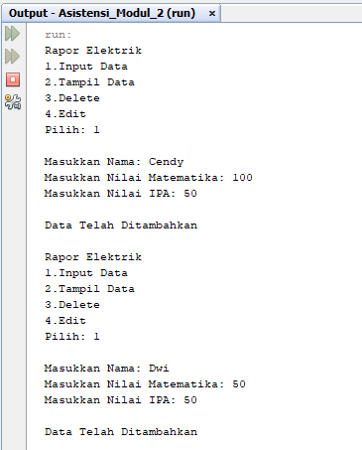

Keterangan Source Code :

------------------------------------------------------------------------------------------------------------------------------------------------------------------------------------------------------------------------------------------------------------------------------------------------------------------------------------------------------------------------------------------------------------------------------------------------------------------------------------------------------------------------------------------------------------------------------------------------------------------------------------------------------------------------------------------------------------------------------------------------------------------------------------------------------------------------------------------------------------------------------------------------------------------------------------------------------------------------------------------------------------------------------------------------------------------------------------------------------------------------------------------------------------------------------------------------------------------------------------------------------------------------------------------------------------------------------------------------------------------------------------------------------------------------------------------------------------------------------------------------------------------------------------------------------------------------------------------------------------------------------------------------

Print Out Source Code Program

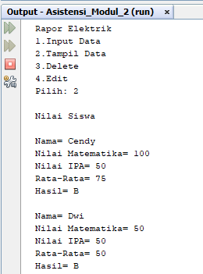

Keterangan Source Code :

------------------------------------------------------------------------------------------------------------------------------------------------------------------------------------------------------------------------------------------------------------------------------------------------------------------------------------------------------------------------------------------------------------------------------------------------------------------------------------------------------------------------------------------------------------------------------------------------------------------------------------------------------------------------------------------------------------------------------------------------------------------------------------------------------------------------------------------------------------------------------------------------------------------------------------------------------------------------------------------------------------------------------------------------------------------------------------------------------------------------------------------------------------------------------------------------------------------------------------------------------------------------------------------------------------------------------------------------------------------------------------------------------------------------------------------------------------------------------------------------------------------------------------------------------------------------------------------------------------------------------------------------

Print Out Source Code Program

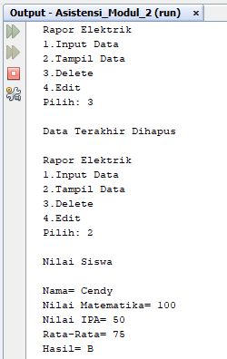

Keterangan Source Code :

------------------------------------------------------------------------------------------------------------------------------------------------------------------------------------------------------------------------------------------------------------------------------------------------------------------------------------------------------------------------------------------------------------------------------------------------------------------------------------------------------------------------------------------------------------------------------------------------------------------------------------------------------------------------------------------------------------------------------------------------------------------------------------------------------------------------------------------------------------------------------------------------------------------------------------------------------------------------------------------------------------------------------------------------------------------------------------------------------------------------------------------------------------------------------------------------------------------------------------------------------------------------------------------------------------------------------------------------------------------------------------------------------------------------------------------------------------------------------------------------------------------------------------------------------------------------------------------------------------------------------------------------

Print Out Source Code Program

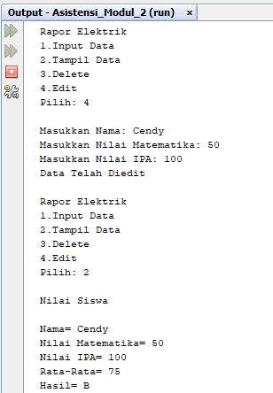

Keterangan Source Code :

------------------------------------------------------------------------------------------------------------------------------------------------------------------------------------------------------------------------------------------------------------------------------------------------------------------------------------------------------------------------------------------------------------------------------------------------------------------------------------------------------------------------------------------------------------------------------------------------------------------------------------------------------------------------------------------------------------------------------------------------------------------------------------------------------------------------------------------------------------------------------------------------------------------------------------------------------------------------------------------------------------------------------------------------------------------------------------------------------------------------------------------------------------------------------------------------------------------------------------------------------------------------------------------------------------------------------------------------------------------------------------------------------------------------------------------------------------------------------------------------------------------------------------------------------------------------------------------------------------------------------------------------